**Ideation Phase**

**Brainstorm & Idea Prioritization Template**

|  |  |
| --- | --- |
| Date | 30-10-2025 |
| Team ID | NM2025TMID02430 |
| Project Name | Laptop Request Catalog Item |
| Maximum Marks | 100 Marks |

**Brainstorm & Idea Prioritization :**

The brainstorming and idea prioritization process for a laptop request catalog item should focus on maximizing user experience and IT efficiency. A structured approach using brainstorming techniques and an idea prioritization framework can help identify and rank improvements effectively.

**Step-1: Team Gathering, Collaboration and Select the Problem Statement**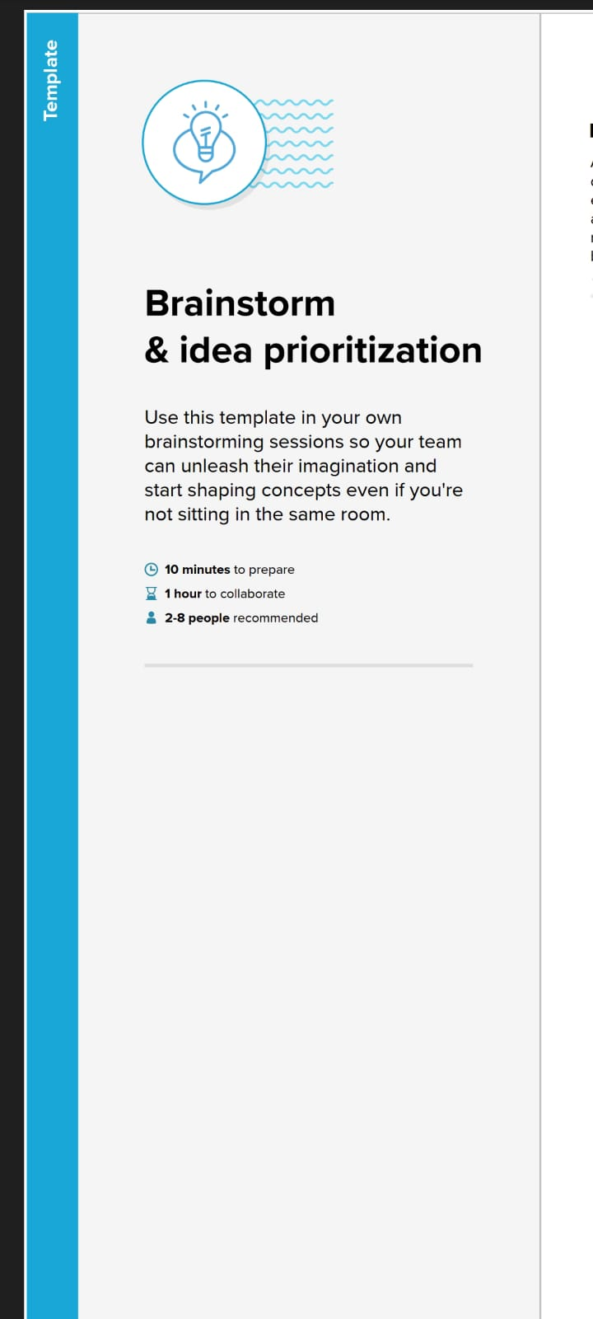

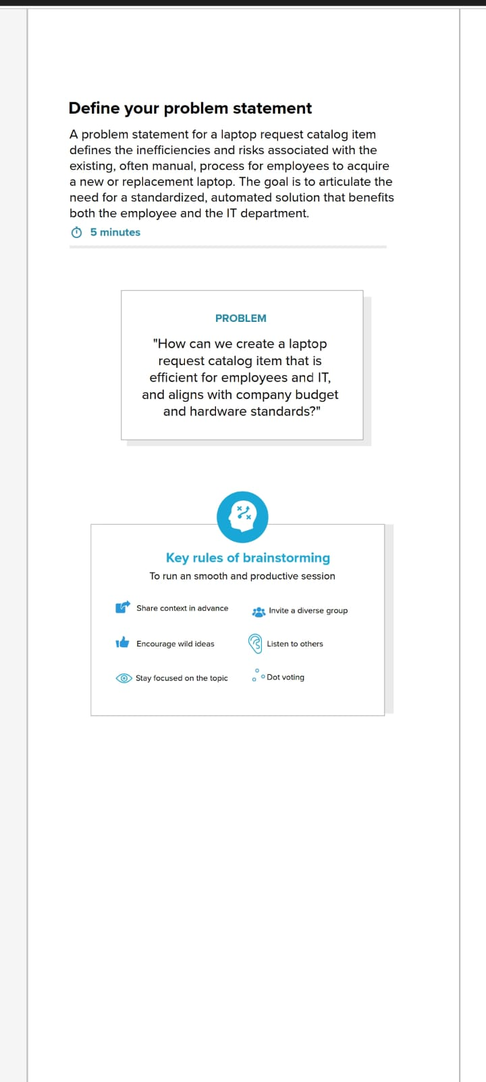

**Step-2: Brainstorm, Idea Listing and Grouping**

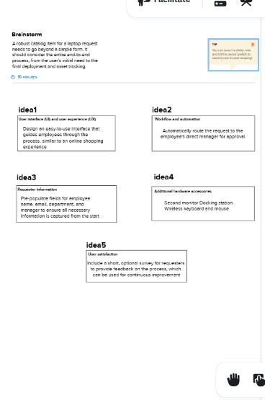

**Step-3: Idea Prioritization**

